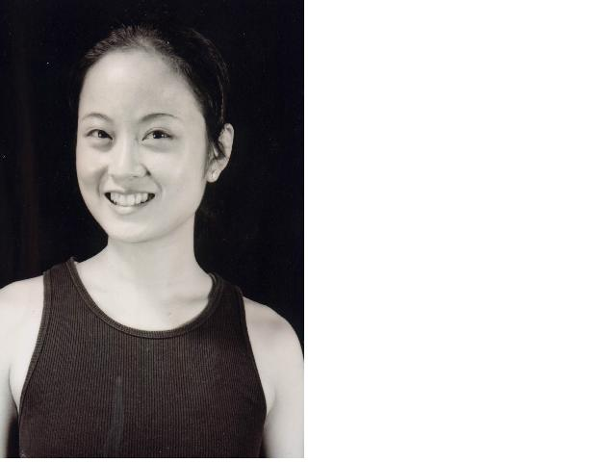
Yi-Ching Chen （Eugen）
Telephone: 011-886-2-2733-7346
Cell phone: 011-886-9-2882-3636
E-mail Address: chen3030@yahoo.com.tw
Address: 4F-2, No33, Ln98, Sec3, HePing E Rd,Taipei 106, Taiwan
Education: 06/2002 M.A. in National Taiwan College of Physical Education
06/1999 B.F.A in Taipei National University of the Arts

I graduated from the Department of Dance, Taipei National University of the Arts .My major was Modern Dance. While I was there, I took courses of Ballet, Chinese Opera Movements, Taichi- Kun, Improvisation, Contact Improvisation, Music for Dancers, Anatomy of Dance, Dance History, etc. I also assisted with production of graduation concert.

During my college years, I took part of the production ,such as<Wind Field>by Ms.Kie Takie, Japanese choreographer. <California Diary> <Phoniex> by Mr.Ross Parkes, American choreographer. <Women Song>by Mr. Cliff Keuter. <Moon Dance><River of Starts>by Mr. Kong Ho-Ping, Chinese Folk Dance choreographer. I was also a leading role as a bride in Lin Hwai-Min’s outstanding piece,<Legacy>.

In1996,I participated Henry Yu Dance Co. and represented <the Story of Yu Hsiuan-chi>. In 1997, I performed in the International Dance Festival of Hong Kong. In the same year, I joined Acme Physical Theater, touring around Taiwan.
During 1999-2001, I was selected as a full- time job dancer of Taipei Dance Circle,
and started learning Yoga, 42 Steps of Taichi- Kun, ”Mind,Body,Chi of body work ” , and baby oil techniques. In this modern dance group, I also represented < Black Tide> in1999, < Fault> <Ode to a Paramecium> in 2000, < Divine Comedy> in 2001. All of those dance pieces were presented in the Dance Festivals all over the world, including “Taipei Theater of Chinese Information and Culture Center”in New York, “Theatre Jean Vilar”in Paris, ”Kallong Theatre ’’in Singapore, “NJPAC”in New Jercey , “Laughing Stone ”in Jucsan of Korea, “Setagaya Public Theatre”in Tokyo, etc.

In 2002, I graduated from National Taiwan College of Physical Education with a Master degree of Physical Education（M.A.）. My master thesis is <Body Perspective of TaiChi From the Thought TaiChi- Kun > granted by National Center for Traditional Arts. In the same year, I became a lecturer in Department of Sport and Leisure in the National Don-Hwa University. I have taught courses of Body Awareness, Taichi- Kun, Yoga, Aerobic, Creative Dance, Fitness, etc. till now.

Additional Experience:
2004 Choreographed < the Tao of Light> with light designer Alia Hong, and granted by National Culture and Arts Foundation (NCAF), performed in Huashan Theatre.
2004 Taught Body Work and Adapted Physical Education for mentally handicapped students of Corner Theatre.
2003 Selected as a young contemporary choreographer from National Theatre,
represented and choreographed<Crossing Light 1 ½> in New Idea Dance .
2003 Choreographed <Parvati >for National Don-Hwa University（NDHU）.
2002 Taught and choreographed <Stop, See and Listen> for Blind Theater Group in the second Colorful Fantasy Festival.
2002 Choreographed <ice tear> for White Temple of Dance.
2001 Created<Light ,Breathing and Body> with Krakow choreographer Carmen Sterland and Kobalt Works choreographer Wenchi Su, granted by National Culture and Arts Foundation (NCAF).
1999 Won the Special Choreographer prize with the piece<Fighting in the Dark>
taught Modern Dance at Dance Art Organization.
1998 Created<Black and White Shadow>
taught Children Dance at Lio Win-Chin Organization
1997 Created <Chasing at Noon><Wind、Moon and Window>< the edge>
and made the <Video Dance Editing> cooperated with Australian Arties Cazerine.
1996 Selected as the Student President of the Dance Department in TNUA
1995 Created<crazy> for Hot Dance Club of Don-Wu University, won the Hot Dance Champion.

